**MINI PROJECT**

**RADIANCE RESIN ART WORK**

Project proposal for small entrepreneur submitted to

Manonmaniam Sundaranar University

In partial fulfillment of the requirements for the

Degree of

**BACHELOR OF COMMERCE**

**BY**

**A.ASWATHI**

**(REG.NO: 20224012304109)**

**Under the Guidance of**



**MANONMANIAM SUNDARANAR UNIVERSITY**

**TIRUNELVELI - 627 012**

**November 2022**

**CERTIFICATE**

Manonmaniam Sundaranar University

Tirunelveli-12

CERTIFICATE

This is to certify that the Mini Project Proposal for Small Entrepreneur report entitled RADIANCE RESIN ART –is based on the original work done by A. ASWATHI in DEPARTMENT OF COMMERCE, Manonmaniam Sundaranar University, Tirunelveli during the academic year 2024-2025 and it has not previously formed the basis for the award of any Degree, Diploma, Associate ship, Fellowship or similar title and that it represents entirely independent work on the part of candidate.

**Place: Tirunelveli**

**Date: GUIDE AND SUPERVISOR**

**DECLARATION**

A.ASWATHI,

III M.com (INTEGRATED),

REG.NO:20224012304109,

DEPARTMENT OF COMMERCE,

MANONMANIAM SUNDARANAR UNIVERSITY,

TIRUNELVELI-12

**DECLARATION**

I hereby declare that the Mini Project Proposal for Small Entrepreneur report entitled RADIANCE RESIN ART submitted to the Manonmaniam Sundaranar University, for the award of the Degree of Bachelor of Commerce is a record of the my original worked done by me, under the guidance and supervision of Department of Commerce it has not formed previously formed the basis for the award of any Degree/Diploma/Associate ship/Fellowship of any university or Similar title.

Place : Tirunelveli (A.ASWATHI)

Date : Candidate Signature

**ACKNOWLEDGEMENT**

**ACKNOWLEDGEMENT**

First of all I thank the almighty God for showing his grace upon us complete my Mini Project Proposal for Small Entrepreneur work successful, whose grace has been sustain us during our study span in this glorious institution.

I express my sincere thanks to

and Head of the Department of Commerce, Manonmaniam Sundaranar University, Tirunelveli, for providing the facilities that I needed to complete the mini project report.

I express my profound gratitude to my guide and

Manonmaniam Sundaranar University Tirunelveli, what so ever I write here in the form of acknowledgement is not sufficient for her constructive criticism. Inspiring guidance and magnetos help ender during the mini project report. I deem it a proof privilege to be under guidance in my academic year.

I express my sincere thanks to all faculty members, Department of Commerce, Manonmaniam Sundaranar University, Tirunelveli for their encouragement to carry out my mini Project report.

I wish to express my profound gratitude to MY PARENTS AND MY FRIENDS who encouraged me a lot and gave valuable suggestions which made me enthusiastic to complete my research in an efficient way.

A.ASWATHI

CONTENTS

|  |  |  |
| --- | --- | --- |
| S.NO | TITLE | PAGE NO |
| 1 | INTRODUCTION |  |
| 2 | PRODUCTION FEASIBILITY |  |
| 3 | MARKETING FEASIBILITY |  |
| 4 | TECHNICAL FEASIBILTY |  |
| 5 | FINANCIAL FEASIBILITY |  |
| 6 | CONCLUSION |  |

**RADIANCE RESIN ART WORKS**

**INTRODUCTION**

Resin art has rapidly gained popularity in the art and craft world, attracting both amateur artists and professional designers due to its versatility, durability, and visual appeal. This section explores the current landscape of resin art, including its market profile, business profitability, demand, and the advantages and benefits of this artistic medium.

Resin art allows for endless creativity and is a versatile medium for creating beautiful, glossy, and long-lasting artwork. This report details the steps taken, materials used, techniques applied, and outcomes of the project.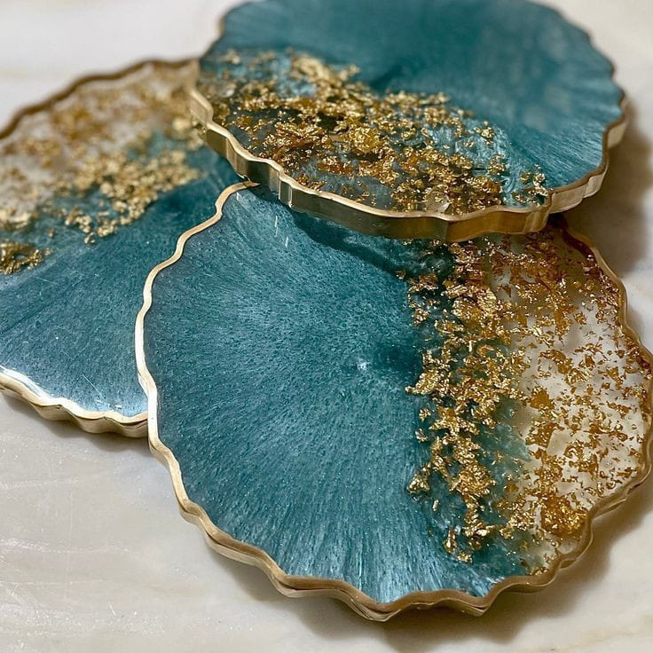

**1.1 Market Profile**

|  |  |  |
| --- | --- | --- |
| **NAME OF THE FIRM :** | | RADIANCE RESIN ART |
| **DATE OF ESTABLISHMENT:** | | 02\01\2024 |
| **ADDRESS , LOCATION :** | | 1\4, ALANGULAM MAIN ROAD, SOUTH STREET, TENKASI. |
| **CONTACT NUMBER :** | | 90908 80809 |
| **TYPES OF PRODUCTS:** | | KEYCHAINS, JEWELLS, WALL HANGING, GIFTS ETC.., |
| **TYPE OF FIRM** | SMALL SCALE FIRM | |

COMPANY`S LOGO:

Resin art occupies a growing niche within the broader arts and crafts market. With the rise of social media platforms like Instagram and Pinterest, resin art has gained significant visibility, encouraging hobbyists and creators to share their designs with a wide audience.

According to recent market studies, the global epoxy resin market was valued at over $7 billion USD in 2023, with a substantial portion dedicated to art, crafts, and small-scale projects. The growth of the DIY (Do It Yourself) community has further boosted the popularity of resin-based products. Many resin artists sell their work online via platforms like Etsy or at local art fairs and boutiques, highlighting resin art as a viable business venture for creative individuals.

**1.2 Business Profits**

Resin art can be a highly profitable business for those who can produce high-quality, unique, and marketable pieces. While the initial investment in materials such as resin, pigments, molds, and safety equipment can be relatively high, the profit margins are significant once the artist establishes a presence in the market.

Products such as custom-made coasters, jewelry, wall art, and even resin furniture can command premium prices, especially when they feature intricate designs or embedded objects like dried flowers, stones, or even personal mementos. Additionally, the scalability of resin art businesses offers opportunities to cater to a wide range of customers, from individual buyers to interior designers and corporate clients looking for custom pieces.

**1.3 Demand**

The demand for resin art has seen a considerable rise due to its unique aesthetic and customization potential. Consumers are drawn to the glossy, high-end look that resin provides, especially for home decor items like coasters, trays, and wall art. This demand has been especially strong in countries with burgeoning middle-class populations and an increasing interest in home improvement and personalized decor, such as in North America, Europe, and parts of Asia.

Moreover, the flexibility of resin to mimic other materials like glass, stone, and ceramic at a lower cost makes it an attractive option for consumers who desire luxury without breaking the bank. The demand is not only from individual customers but also from businesses looking for custom branded gifts or designers seeking unique elements for their projects.

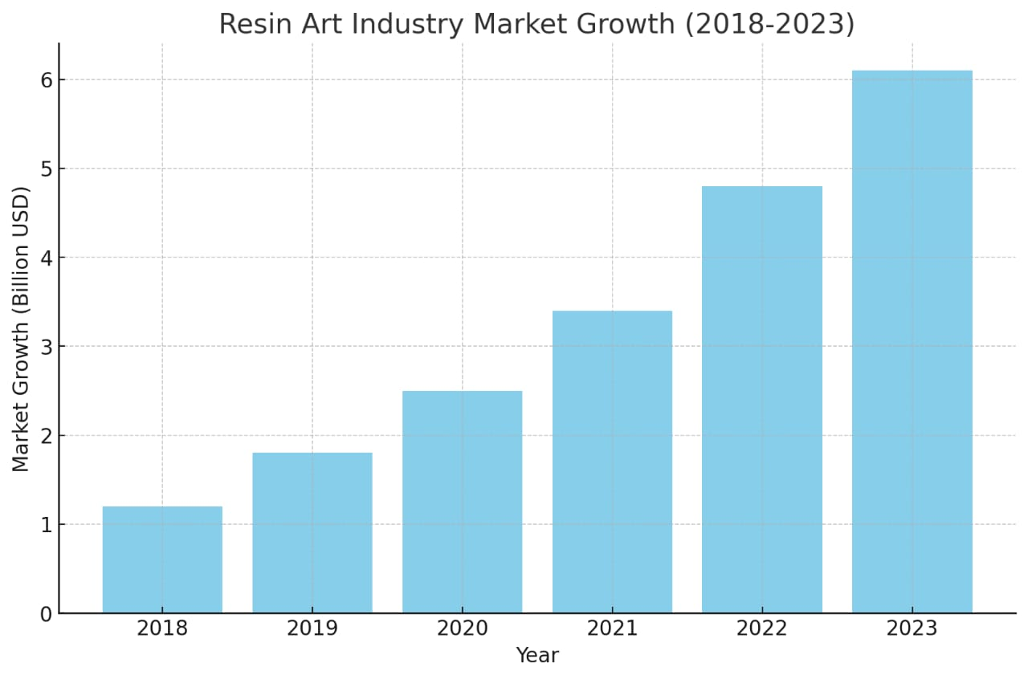

**1.4 Advantages and Benefits**

Resin art offers several advantages, making it an appealing choice for both creators and consumers:

* **Durability:** Resin pieces are known for their strength and resistance to wear and tear. Unlike traditional art mediums, resin products are less likely to break, chip, or degrade over time, making them ideal for functional items like tables, coasters, or jewelry.
* **Versatility**: Epoxy resin can be combined with a wide range of pigments, additives, and materials such as wood, metal, flowers, or stones. This versatility allows artists to create anything from transparent, glass-like structures to opaque, richly colored artworks.
* **Customization**: The ability to create custom pieces is a major draw of resin art. Customers can request specific colors, patterns, or embedded objects, making resin art a popular option for personalized gifts, memorabilia, and interior decor.
* **High-End Aesthetic**: Resin's glossy finish gives it a luxurious look, which appeals to customers seeking elegant, modern decor. This high-end aesthetic can be achieved at a fraction of the cost of materials like glass or marble, offering both affordability and beauty.
* **Artistic Freedom**: For artists, resin opens up endless creative possibilities. The medium can be used in various forms—from large-scale paintings to intricate jewelry—and its liquid nature allows artists to experiment with layering, marbling, and other techniques not easily achieved with traditional paints or sculpture.

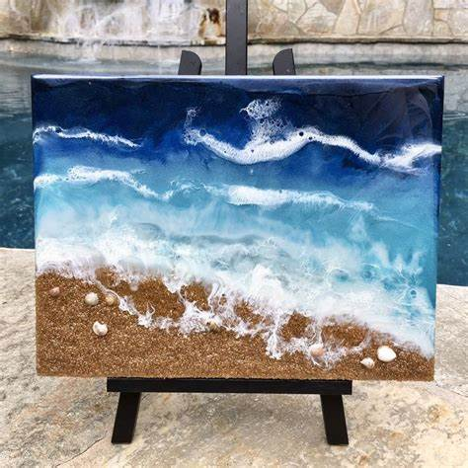

**PRODUCTION FEASIBILITY**

**Material Availability**

The essential materials required for resin art production—epoxy resin, hardeners, pigments, and molds—are readily available through both local suppliers and online platforms. Many resin products are imported from global manufacturers, with major supplies coming from countries like the USA, China, and Germany. This easy access to materials ensures that production can be sustained without major interruptions.

However, ensuring a steady supply of high-quality resin and additives is crucial, as lower-grade materials can lead to poor finishes, yellowing over time, or failed curing processes. It’s important to establish reliable supplier partnerships to guarantee consistent material quality and availability.

**Preparation of Workspace**

The first step is to ensure that the workspace is properly set up and well-ventilated, as resin emits fumes that can be harmful if inhaled over long periods. Key considerations include:

* **Surface Protection:** Cover your work surface with a plastic sheet, wax paper, or any non-porous, disposable material to avoid resin spills sticking to the surface.

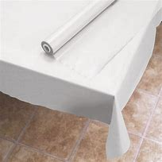

* **Ventilation:** Ensure there is sufficient airflow in the workspace to reduce exposure to fumes.



* **Safety Gear**: Wear gloves, an apron, and a mask to protect your skin and lungs from resin fumes and splashes

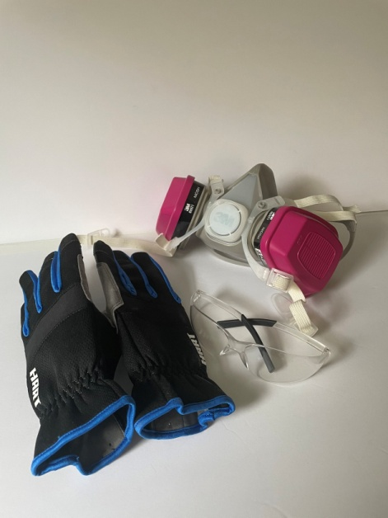

* **Tools Ready:** Arrange all necessary tools and materials (measuring cups, stir sticks, heat gun, pigments, etc.) before starting, as resin begins to set relatively quickly once mixed.

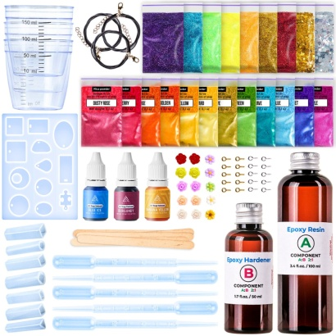

**Measuring and Mixing Resin**

Resin typically consists of two components: the resin itself and a hardener, which need to be mixed in a specific ratio (commonly 1:1 or 2:1, depending on the product). This step is crucial for achieving the correct consistency and ensuring proper curing:

* **Measuring:** Use clear, disposable measuring cups to ensure the right ratio of resin to hardener. It is essential to measure accurately, as an incorrect ratio will affect the curing process and result in a sticky or soft finish.



* **Mixing:** Slowly stir the resin and hardener together for 3-5 minutes, ensuring it is thoroughly mixed. Scrape the sides and bottom of the container to incorporate all the resin. Avoid stirring too vigorously to minimize air bubbles.

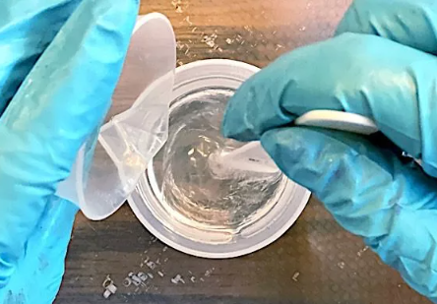

**Adding Pigments and Colors**

Once the resin is mixed, it's time to add color or other design elements. Depending on the effect you want to achieve, you can use:

* Alcohol Inks: For bright, translucent colors.
* Mica Powders: For metallic or pearlescent finishes.
* Acrylic Paints: For solid, opaque colors (make sure these are resin-compatible).
* Glitters: For adding sparkle and texture.

After adding pigments, mix thoroughly to distribute the color evenly throughout the resin.

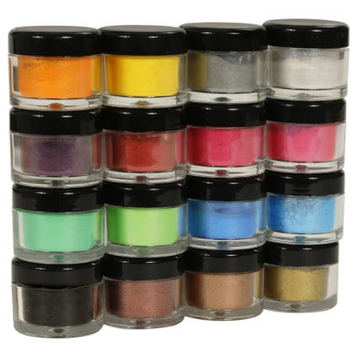



**Pouring the Resin**

Once the resin is colored and mixed, it is poured into the desired mold or onto a flat surface (for larger art pieces). There are several techniques for pouring resin, depending on the look you want to achieve:

* Direct Pour: Simply pour the resin into the mold or onto the surface in a free-flowing manner, allowing the czolors to blend and create natural designs.
* Layering: Pour in layers, allowing one layer to partially cure before adding the next to create depth or keep colors distinct.
* Marbling Effect: Pour different colors in various areas and use a stir stick to swirl them together for a marbled appearance.

When pouring resin, it’s important to work quickly but carefully, as the resin will start to set within 20-30 minutes after mixing.



**Eliminating Air Bubbles**

Air bubbles can form during the mixing and pouring process, and removing them is essential to ensure a smooth, glass-like finish. Common methods to remove bubbles include:

* **Heat Gun:** Gently wave a heat gun over the surface of the resin to help the bubbles rise and pop.



* **Torch**: A small butane torch can be used for larger projects to eliminate stubborn bubbles quickly.
* **Toothpick:** For small, intricate pieces or molds, use a toothpick to manually pop any remaining bubbles.

**Embedding Objects**

If you plan to embed objects (such as dried flowers, stones, or small trinkets) into the resin, carefully place them into the mold or on the surface after pouring the first layer of resin. Ensure the object is fully submerged in the resin or add additional layers to cover it. It’s important to anchor lightweight objects, like flowers, so they do not float to the surface during curing.



**Curing Process**

Once the resin is poured and the design is complete, the piece must be left to cure:

* Curing Time: Resin typically takes 24-48 hours to fully cure, though the initial set may occur within 12 hours. During this time, ensure the workspace remains dust-free and undisturbed to avoid imperfections in the finish.
* Temperature Control: The ideal curing temperature for epoxy resin is between 70-75°F (21-24°C). Colder temperatures may result in slower curing, while warmer conditions can accelerate the process but risk imperfections like warping or bubbles.

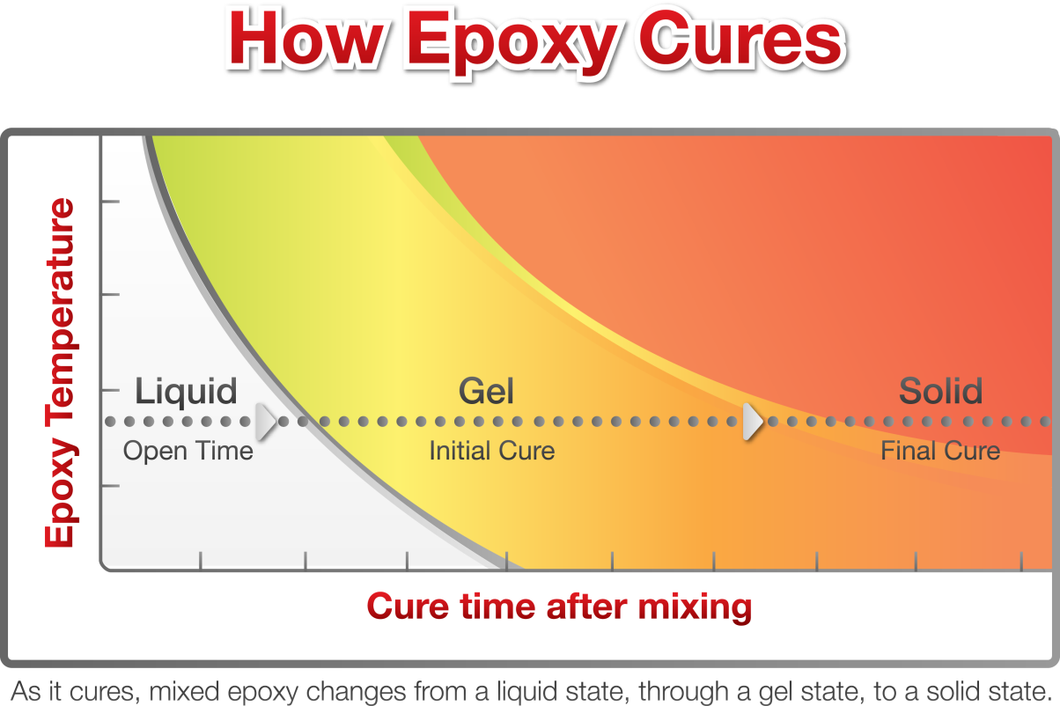

**Unmolding and Finishing**

Once the resin has fully cured, the next step is to remove it from the mold or finalize the flat surface piece:

* **Unmolding:** Gently flex the silicone mold to release the resin piece. If it resists, allow more curing time before trying again.
* **Finishing Edges**: If the edges of the piece are rough or sharp, sand them down with fine-grit sandpaper or a Dremel tool.
* **Polishing:** For a high-gloss finish, you can polish the resin using a resin-specific polish or a simple household polish. Buff the surface with a soft cloth to achieve a brilliant shine.

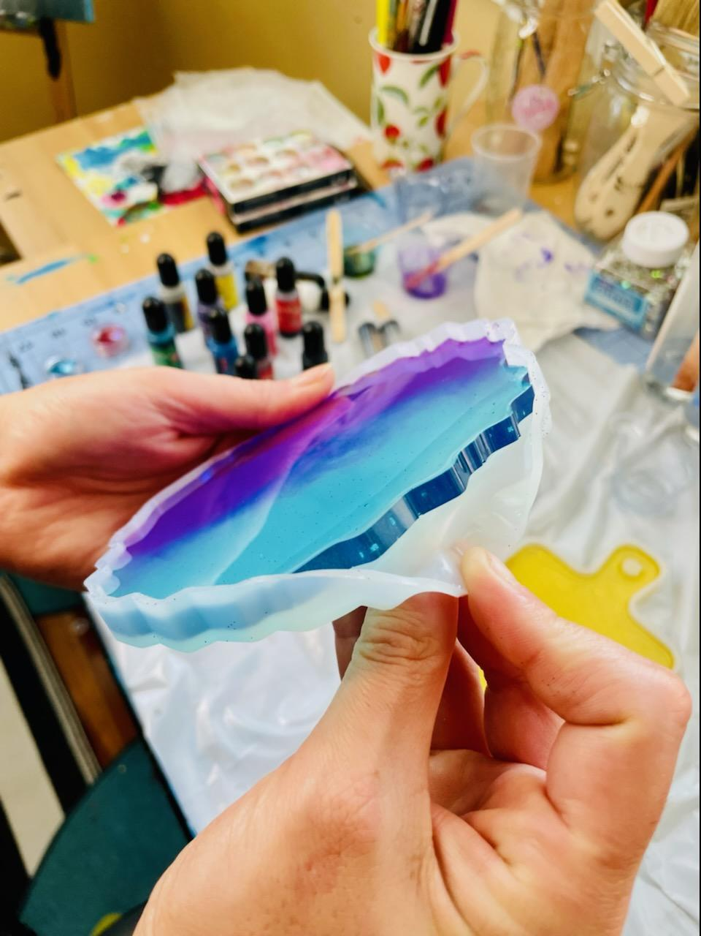

Optional: Apply an additional clear topcoat of resin for a thicker, glossier look, especially on flat pieces like coasters or trays.

**Final Product Inspection**

The final step is to inspect the resin art for any imperfections:

* **Surface Quality**: Ensure there are no dust particles, bubbles, or uneven textures.
* **Curing Success:** Check that the resin has fully hardened, is not tacky to the touch, and is durable.
* **Color and Design:** Review the overall design to confirm that the colors are vivid and any embedded objects are positioned as intended.

**Time Management**

One challenge in resin art production is the curing time required for epoxy resin. Most resins take 24-48 hours to fully cure, which can delay production, especially for larger pieces or projects requiring multiple layers of resin. This requires careful planning, especially if orders need to be fulfilled within tight deadlines.

However, the production process can be optimized by working on multiple pieces simultaneously. While one layer is curing, other pieces can be prepped or poured, allowing the artist to work more efficiently. Utilizing faster-curing resins (such as UV resins) for smaller or urgent pieces is another solution, although they tend to be more expensive.



**MARKETING FEASIBILITY**

Market feasibility assesses the potential for success in bringing resin art products to market. It considers the demand, target audience, pricing strategies, and logistical elements involved in production and distribution. The following sections outline a marketing plan and supply chain management considerations for resin art.

**Marketing Plan**

A strong marketing plan is essential to ensuring resin art products reach the right audience and generate consistent demand. This section covers the target market, promotional strategies, and pricing considerations.

**Target Market**

The target market for resin art is diverse and can include various segments, such as:

* **Home Decor Enthusiasts:** Resin art, with its glossy finish and modern aesthetic, appeals to individuals looking for unique and customizable decor items like coasters, wall art, and trays.



* **Gifting Market**: Customizable resin pieces make excellent personalized gifts for weddings, birthdays, or corporate gifting. This segment is especially lucrative for one-of-a-kind items.

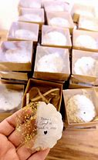

* **Jewelry Collectors:** Handmade resin jewelry, such as pendants, earrings, and bracelets, can attract buyers looking for distinctive accessories.

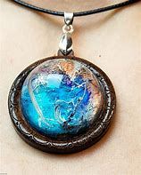

* **Interior Designers and Businesses:** Resin furniture and larger art pieces can appeal to designers, hotels, restaurants, or businesses looking to incorporate unique decor items into their spaces.

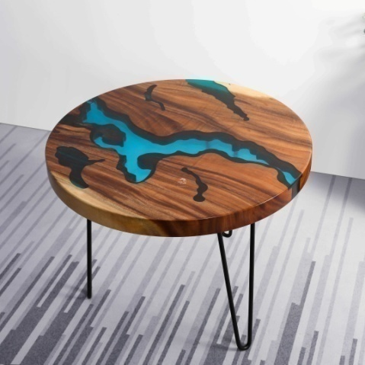

**Promotion Strategies**

Promotion is key to gaining visibility and building a customer base. The following strategies can be used to promote resin art:

* **Social Media Marketing**: Platforms like Instagram, Pinterest, and TikTok are ideal for visually-driven products like resin art. Sharing high-quality photos, time-lapse videos of the production process, and engaging with potential customers can help create a following.



* **Online Marketplaces:** Selling through e-commerce platforms like Etsy, Amazon Handmade, or local art websites can help reach a global audience. Many resin artists have found success by selling on Etsy due to its large audience looking for handmade and unique products.



* **Local Art Shows and Fairs**: Attending local craft fairs, art shows, or pop-up markets can increase brand visibility and generate sales from customers who want to see the product in person.



* **Collaborations:** Partnering with local influencers or other small businesses (e.g., furniture stores, interior designers) can help increase exposure. For example, creating a limited-edition line of resin art pieces for a boutique can drive sales and attract a wider audience.



* **SEO and Website Development:** Having a well-designed website with strong search engine optimization (SEO) can help generate traffic from search engines. Creating blog content on resin art, tutorials, and product guides can help engage potential buyers.



**Pricing Strategy**

The pricing of resin art should account for the cost of materials, labor, and the perceived value of the artwork. Factors to consider include:

* **Cost-Plus Pricing:** Calculate the total cost of materials, labor, and overhead, then add a profit margin to determine the selling price.
* **Competitor-Based Pricing**: Analyze the prices of similar resin art products in the market. Etsy, Amazon Handmade, and other platforms are good sources for competitor price analysis. Make sure your price aligns with the quality and uniqueness of your product.
* **Value-Based Pricing:** Position resin art as a premium product, especially for customized or large-scale pieces. Customers are often willing to pay more for unique, handmade, or personalized art, particularly in the home decor and gift markets.
* **Bundle Offers:** Offering bundles, such as sets of coasters or jewelry, can incentivize larger purchases and increase the average order value.



**Inventory Management**

Effective inventory management is crucial for minimizing waste and ensuring that orders are fulfilled promptly. Key considerations include:

* **Raw Material Stock**: Maintain an adequate inventory of resin, pigments, and molds to avoid delays in production. Track usage rates and reorder materials well in advance to avoid stockouts.
* **Finished Goods Inventory:** If offering pre-made resin art pieces (rather than custom orders), it’s important to maintain enough inventory to meet demand, especially during peak seasons such as holidays. Using inventory management software can help track stock levels and avoid overproduction.
* **Customization Supplies:** If offering personalized or custom-made products, ensure that specific materials (e.g., custom molds, specific pigments) are ordered and available to meet customer requests.

**Production Planning**

Efficient production planning helps reduce lead times and ensures that customer orders are fulfilled in a timely manner. Consider the following:

* **Batch Production:** Group similar orders together to reduce production costs and time. For instance, producing multiple coasters or jewelry pieces in the same color palette or design can streamline the process.
* **Production Schedule:** Create a production schedule based on order volume and lead times. This is especially important for resin art, as each layer of resin must cure before additional layers can be added.
* **Outsourcing:** As the business grows, consider outsourcing certain tasks, such as packaging or shipping, to save time and focus on creating new designs.

**Logistics and Distribution**

Efficient logistics are key to delivering products safely and on time. Resin art pieces, especially those involving custom designs, are delicate and need careful handling during shipping. Key considerations include:

* **Packaging**: Resin art products need to be carefully packaged to avoid damage during shipping. Use bubble wrap, foam inserts, and sturdy boxes to protect the items.

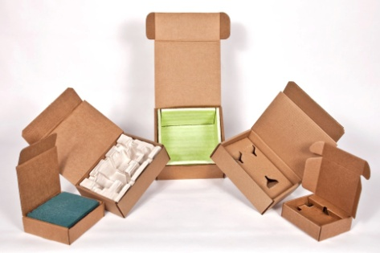

* **Shipping:** Partner with reliable shipping carriers who can deliver products on time. Offering customers various shipping options (e.g., standard, express) can improve satisfaction.



* **Tracking and Returns**: Provide customers with tracking information and implement a clear return policy for damaged or unsatisfactory items. This helps build trust and ensures a positive customer experience. 

**TECHNICAL FEASIBILITY**

Resin art manufacturing involves creating artistic pieces using epoxy resin, a versatile polymer that hardens to a glossy, durable finish. The process requires a combination of chemical mixing, artistic techniques, and proper environmental conditions for curing. This report assesses the technical feasibility of establishing a resin art manufacturing business, considering the required technology, skills, production workflow, and environmental factors.

**REQUIRED EQUIPMENT:**

**1. UV light:**

1. Work in thin layers. UV resin is suitable for small objects or thin layers.
2. Select a UV lamp or flashlight with an output of at least 4 watts. A strong light source is necessary to properly cure your resin artwork.
3. Add a thin layer of resin to your object and cure it with the UV lamp. The curing time may vary depending on the resin and the lamp, but it usually takes a few minutes.
4. Add new layers and cure them until you reach the desired thickness. Make sure each layer is fully cured before adding the next one.



**2. Heat Gun:**

Heat guns are very useful when making resin art. Whether you are creating resin jewelry, resin painting, geode resin art, epoxy glitter tumblers, coasters or more, these are the best tools to always have on hand to **remove bubbles from your wet resin**. Heat guns are also amazing tools to push the flow of your resin around.

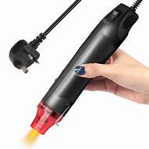

**SWOT Analysis for Resin Art Business**

**Strengths:**

1. **Unique and Creative Products**: Resin art offers distinctive, customized items that appeal to consumers seeking personalized decor.
2. **Growing Trend**: The popularity of DIY crafts and home decor has increased demand for resin art products.
3. **Low Barrier to Entry**: The materials and tools required to start are relatively affordable, making it accessible for beginners and artists.
4. **Diverse Product Range**: Ability to create various products (e.g., coasters, jewelry, wall art), allowing for market diversification.
5. **Online Presence**: Strong potential for marketing through social media platforms, which can reach a wide audience.

**Weaknesses:**

1. **Initial Investment**: Significant upfront costs for materials, tools, and marketing can be a barrier for new entrepreneurs.
2. **Learning Curve**: Requires skill and practice to master techniques, which may deter some potential artists.
3. **Safety Concerns**: Handling epoxy resin requires safety precautions (e.g., gloves, masks), which can complicate the production process.
4. **Time-Consuming Production**: Creating intricate designs can be labor-intensive, impacting profitability and production capacity.

**Opportunities:**

1. **Expanding Market**: Increasing demand for handmade and personalized items creates room for business growth.
2. **Collaborations and Partnerships**: Opportunities to partner with local businesses, artists, and influencers to expand reach.
3. **Workshops and Classes**: Offering resin art workshops can diversify income streams and build a community around the brand.
4. **Online Sales Platforms**: Utilizing e-commerce platforms can enhance sales opportunities, reaching customers beyond local markets.
5. **Customization**: High demand for customized products allows for the potential to cater to specific customer needs and preferences.

**Threats:**

1. **Intense Competition**: The market for handmade crafts is saturated, with many artists vying for consumer attention.
2. **Changing Trends**: Fluctuating consumer interests in home decor may impact product demand.
3. **Economic Factors**: Economic downturns can lead to reduced discretionary spending on luxury items like decorative art.
4. **Material Costs**: Fluctuating prices for resin and other materials can affect profit margins and overall business sustainability.
5. **Regulatory Changes**: Changes in safety regulations or environmental standards related to materials used in resin art could pose challenges.

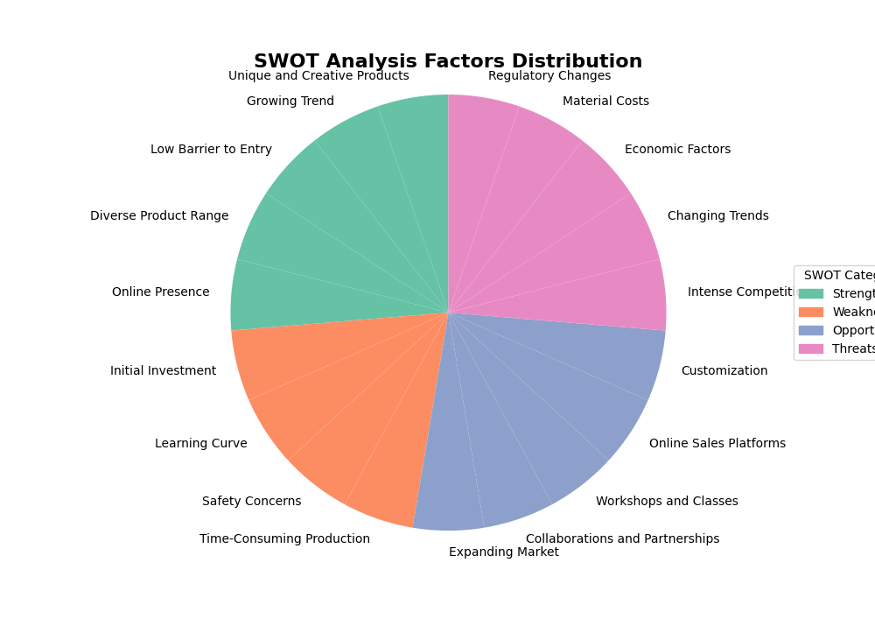

This SWOT analysis provides a clear overview of the internal strengths and weaknesses of the resin art business, as well as the external opportunities and threats it may face. By leveraging strengths and opportunities while addressing weaknesses and threats, the business can strategically position itself for success in the market.

**Scalability**

Scaling up a resin art business is feasible, but it comes with additional challenges. For instance:

* Production Space: Resin art requires a well-ventilated workspace, and larger-scale production demands even more space to accommodate curing pieces, storage of materials, and production tools. Artists looking to expand may need to rent or build dedicated studio spaces.
* Workforce: As demand grows, additional skilled labor may be needed to handle more complex orders, ensure product quality, and increase production output. Training employees in resin art techniques and safety is essential to maintain consistency.
* Equipment: Large-scale resin production may require investing in higher-grade equipment, such as industrial mixers, automated pouring machines, and improved ventilation systems to handle increased resin use safely.



**FINANCIAL FEASIBILITY**

Financial feasibility is the ability of a proposed business or investment to generate positive cash flow and meet other financial objectives. It is determined by calculating the projected costs and revenues of the proposed venture, and then determining if the expected returns justify the costs.

There are many factors that can affect financial feasibility, including the size and complexity of the project, the market conditions, and the company's own financial resources. A company may be able to overcome some financial challenges, but others might be too great.

**EQUIPMENTS:**

|  |  |
| --- | --- |
| **MATERIALS** | **AMT** |
| RESIN TANK ( 20 LTR CAPACITY) | 1500 |
| MIXING MACHINE | 2000 |
| MOLDS | 5500 |
| HEAT GUN | 2000 |
| UV LIGHT | 3000 |
| AIR VENT | 2000 |
| SAFETY GEAR | 1000 |
| WOODEN ICE STICK | 500 |
| OFFICE EQUIPMENTS | 5000 |
| OTHER THINGS | 2500 |
| TOTAL | 25000 |

**RAW MATERIALS:**

|  |  |  |  |
| --- | --- | --- | --- |
| PARTICULAR | QUANTTY | RATES | TOTAL AMT |
| RESIN & HARDNER | 5 L | 1000 | 5,000 |
| PIGMENTS | 5 | 200 | 1000 |
| DRY FLOWERS | 2 | 250 | 500 |
| GOLD & SILVER  FLAKES | 2 | 250 | 500 |
| CRYSTALS & SEASHELLS | 2 | 250 | 500 |
| TOTAL |  |  | 7500 |

**EXPENSES:**

|  |  |
| --- | --- |
| POSTAGE &STATIONERY | 2000 |
| TELEPHONE | 500 |
| MAINTENANCE | 100 |
| OTHER UNFORSEEN | 500 |
| TOTAL | 3100 |

**CAPITAL:**

WORKING CAPTIAL ( P. M ) – 10600

FIXED CAPTIAL – 25,000.

TOTAL WORKING CAPTIAL : 1,27,200

**SALES :**

SALES PER MONTH : 100 * ( 50 – 250) = 15000

SALES FOR 3 MONTH : 8000*3 = 450000

ESTIMATED SALES FOR 1 YEAR = 1,50,000.

**PROFIT PERCENTAGE:**

SALES FOR A YEAR = 1,50,000

PROFIT PERCENTAGE ( 16 %) = 24,000



**CONCLUSION**

This report on the resin art business project provides a comprehensive overview of its feasibility, including market, production, technical, and financial aspects. The findings highlight the potential for a successful and sustainable venture in the resin art sector.

1. **Market Viability**: The resin art market shows promising growth driven by increasing consumer interest in unique and customizable home decor items. A well-defined target audience, combined with effective marketing strategies, can capitalize on this trend, ensuring a steady demand for resin art products.
2. **Production Feasibility**: The production process for resin art is straightforward, with accessible materials and techniques that can be easily mastered. The outlined procedures demonstrate the practicality of creating high-quality products while emphasizing safety measures to mitigate risks associated with resin handling.
3. **Technical Feasibility**: The required equipment and technology for producing resin art are readily available and affordable. With a modest initial investment, the necessary tools and workspace can be established, enabling efficient production and product diversification.
4. **Financial Viability**: The financial analysis indicates that the resin art business can achieve profitability with an estimated initial investment of INR 60,000 to INR 125,500 and manageable monthly operational costs of INR 19,500 to INR 38,000. The potential for generating revenue and achieving net profits of INR 24,500 to INR 43,000 monthly underscores the business’s viability.
5. **Future Opportunities**: As the resin art market evolves, opportunities for expanding product lines and entering new markets may arise. Staying abreast of trends and consumer preferences will be crucial for long-term growth.

In conclusion, the resin art business presents a viable and potentially lucrative opportunity for individuals interested in leveraging their creativity. By focusing on quality, marketing, and customer engagement, aspiring entrepreneurs can build a successful brand in this vibrant and dynamic market. The structured approach outlined in this report serves as a roadmap for launching and sustaining a resin art venture, ensuring both creativity and profitability are harmoniously integrated.